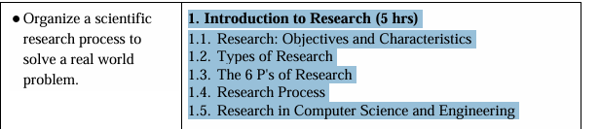
- Explain the 6 P’s of Research. Illustrate how each stage contributes to the success of a research study with examples from IT research.
- “Research is the systematic approach to obtaining and confirming new and reliable knowledge.” Justify this statement and explain the objectives and characteristics of effective research.
- How is research defined and conceptualized within the field of computer engineering? Explain the model of the research process.
- Describe briefly with examples the role of the “6 P’s of Research” in shaping a research project.
- Is research merely an accidental discovery? Discuss the concept and meaning of research, and explain the six P's of research.
- Creativity in the research process
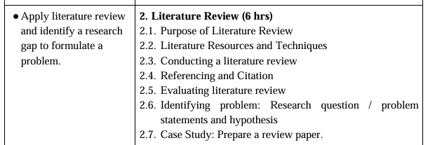

- Compare and contrast different literature sources. Evaluate the effectiveness of systematic vs. narrative review methods in IT research.
- How can conducting a literature review help in identifying a research gap? Choose a specific domain and illustrate the process of finding research gap with a relevant example.
- Why is literature review important in research? How do you conduct a literature review? Explain with examples.
- Explain the difference between referencing and citation. Why is proper citation essential in academic research? Give examples.
- Develop two research titles, objectives, research questions, a problem statement and hypothesis on the topic “Role of AI in medical sciences.” Also explain how a research gap can be found in this particular topic.
- What is a problem statement in research?
- Why is a literature review important in research? As an early-stage researcher, how do you conduct a literature review? Explain.
- Research question and problem_statement

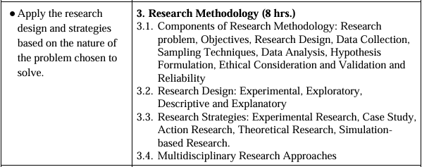

- Explain different research paradigms. How do these paradigms influence the choice of methodology in IT and computer systems research?
- Differentiate between research methodology, research design, and research methods. How do these components interact to ensure a coherent research study in IT?
- Why is research design important? Explain the styles involved in research design.
- What is a problem statement in research, and how are research objectives and research design formulated? Explain their roles and interrelationships.
- Do you think hypothesis testing is necessary in computer engineering research? How is the hypothesis formulated? Explain Type-I and Type-II error.
- What is an explanatory research design? How does simulation-based research differ from experimental research in terms of accuracy and real-world applicability?
- What is a research strategy? Explain the most commonly adopted research strategies in the field of computer engineering.
- Examine different types of research design. Provide examples of their application in IT-related research problems.
- Compare and contrast experimental research, case study, and simulation-based research in the context of solving problems. Discuss their advantages, limitations, and suitability for different types of research problems.
- Explain multidisciplinary approaches to research. Provide examples to support your analysis.
- Suppose you are doing research on “ML-based house price prediction.” Develop a problem statement, research questions, objectives, and hypotheses for this study and justify your choices.
- What is reliability and validity in research? Discuss the importance of research design in computer science and engineering research, and briefly explain key research design techniques.
- What are the key components of research methodology? Briefly discuss.

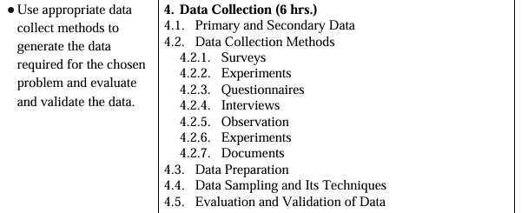
- How is sampling important in research? Explain the different types of probability and non-probability sampling techniques.
- Why is sampling frame important in research? Explain about probability and non-probability sampling techniques.
- Critically assess the influence of different data sampling techniques on the accuracy and generalizability of predictive models in research design.
- What is data coding? How do descriptive and inferential statistics complement each other in research analysis? Provide examples.
- How does data preparation impact the reliability and validity of research outcomes? Critically analyse the role of data cleaning and transformation in ensuring data quality, minimizing bias, and enhancing the robustness of research findings.
- Classify different types of data and variables. How do these classifications influence research design and analysis?
- Types of quantitative data
- Data coding
- Why is data collection essential in computer engineering-related research, and what are the main methods used for collecting the data? Explain.
- Briefly explain the methods used in data collection. What are the ethical challenges associated with survey-based data collection, and how can they be addressed?
- A researcher wants to measure student stress levels using a questionnaire. Calculate Cronbach’s alpha and determine whether the scale is reliable.
- Differentiate between primary and secondary data, and discuss their impact on research outcomes. Explain the basic methods used for data collection.

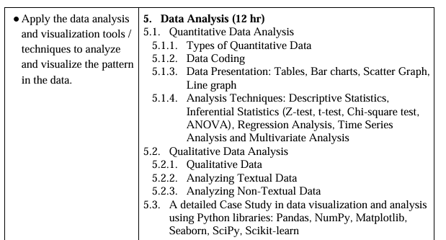
- What is time series data? Explain the basic techniques used in time series analysis.
- How is the t-test different from the z-test? Explain ANOVA and its significance in research.
- Describe the role of multivariate analysis in understanding complex IT data, including server performance indicators, user activity, and transaction records. Further, discuss how techniques such as Principal Component Analysis (PCA) help reduce dimensionality and make the results easier to interpret.
- Explain the Chi-Square test with an example.
- Critically evaluate the role of inferential and descriptive statistics in quantitative research. How do these methods contribute to hypothesis testing and decision-making?
- Describe Grounded Theory, Distributed Cognition, and Activity Theory, and explain their significance in qualitative analysis.
- Why is regression analysis important in research? Briefly explain simple linear and multivariate regression.
- How do you analyze textual and non-textual data? Explain briefly.
- Differentiate between textual and non-textual qualitative data. Discuss the role of coding and thematic analysis in extracting meaningful insights from IT user feedback or software bug reports.
- Briefly explain the techniques used for data presentation and analysis.
- What is the significance of data visualization in quantitative analysis, and how do Matplotlib and Scikit-learn contribute to effective data presentation and interpretation decision-making in research.
- Importance of data visualization
- Discuss the various types of quantitative data and explain the basic techniques for data presentation.
- How do you choose an appropriate measure of central tendency? Explain the role of standard deviation, correlation coefficient and ANOVA in data analysis.
- How hypothesis testing is important in scientific research? A university professor claims that the standard deviation for students taking a research techniques test is less than 30. Ten tests are randomly selected, and the standard deviation is found to be 28.8. Test the professor's claim at the $α$= 0.01 level.
- How sample size is important in research? A study is to be performed to determine a certain parameter (BMI) in a community. From a previous study a standard deviation of 46 was obtained. If a sample error of up to 4 is to be accepted. How many subjects should be included in this study at 99 level of confidence?
- .How is textual data analyzed in research? Explain the basic theoretical frameworks used for qualitative analysis.
- A researcher wants to measure student stress levels using a questionnaire. Calculate Cronbach’s alpha and determine whether the scale is reliable.
- Time Series Analysis and Multivariate Analysis
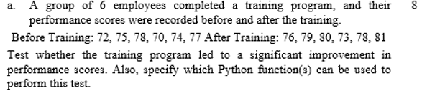
OR
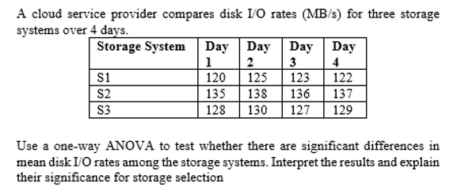
- 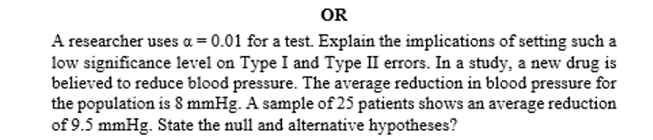

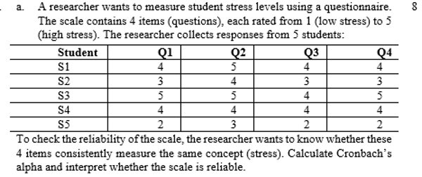

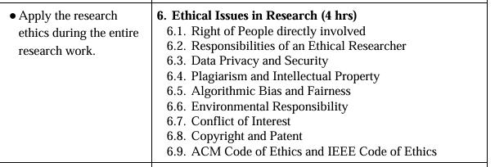

- As an early-stage researcher, how do you write and present your research? Explain.
- What do you mean by data privacy and copyright?How can researchers maintain objectivity when their research is funded by private corporations with vested interests?
- Describe the importance of plagiarism, conflict of interest, patent, and codes of ethics in research.
- Ethical Issues in Research
- Research Ethics
- As an ethical researcher, what are your key responsibilities? Explain the role of intellectual property rights (IPR) in scientific research.

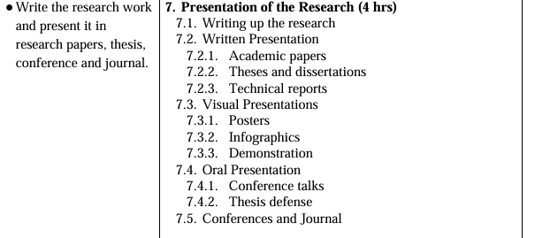
- How does the choice of research presentation format (written, visual, or oral) impact the effectiveness of conveying complex technical-information? Provide examples.
- Explain the essential qualities of a good research report. Outline and describe the critical steps in developing a research proposal.
- How do you approach academic writing? Discuss the basic structure and potential contents of a research proposal.
- As a researcher, how do you prepare and deliver a research presentation? Explain.
